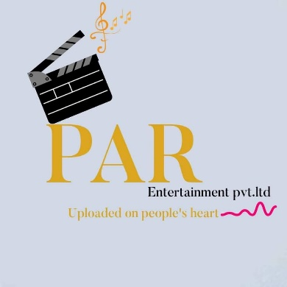

**PAR Entertainment**

**Phone: +9779821947898** **Email: parentertainment03@gmail.com**

To whoever this may concern,

Subject: Regarding Domain Acquisition

PAR Entertainment is a fairly new startup specializing in music production and film making. So far, we have produced a music video which has over 100k views on YouTube. In the future as well, we plan to develop several music videos and web series but in order to do so and hopefully make some profit we need to have a strong online presence and a solid brand recognition. Hence, we have decided that a website is rudimentary for our establishment as an institution.

Therefore, this letter is a humble request to you to provide us the domain “parentertainment.com.np” for our institutions brand recognition.

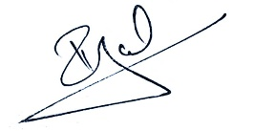 

Pranjal Pokhrel

CEO, PAR Entertainment